Programming Challenge 10-3
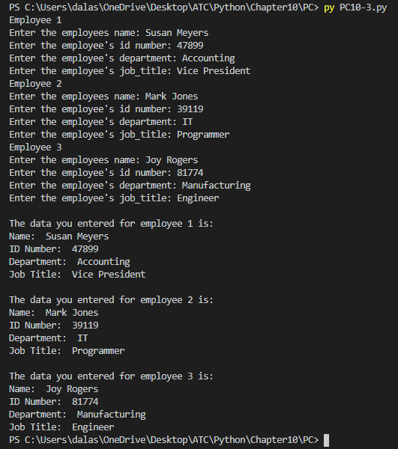

#Employee class program

#define the class
class Employee:
#initialize the class
def __init__(self, name, id_number, department, job_title):
self.__name = name
self.__id_number = id_number
self.__department = department
self.__job_title = job_title

#method to set the employee name
def set_name(self, name):
self.__name = name

#method to set the employee id
def set_id_number(self, id_number):
self.__id_number

#method to set the employee department
def set_department(self, department):
self.__department = department

#method to set the employee job title
def set_job_title(self, job_title):
self.__job_title = job_title

def get_name(self):
return self.__name

def get_id(self):
return self.__id_number

def get_department(self):
return self.__department

def get_job(self):
return self.__job_title

#function to get the employee information
def get_info():
#get employee info from user
name = input("Enter the employees name: ")
id_number = int(input("Enter the employee's id number: "))
department = input("Enter the employee's department: ")
job_title = input("Enter the employee's job_title: ")
return name, id_number, department, job_title

def main():
print("Employee 1")
#get employee1 information
name, id_number, department, job_title = get_info()
#create the instance with the information
employee1 = Employee(name, id_number, department, job_title)

print()
print('Employee 2')
#get employee2 information
name, id_number, department, job_title = get_info()
#create the instance with the information
employee2 = Employee(name, id_number, department, job_title)

print()
print('Employee 3')
#get employee3 information
name, id_number, department, job_title = get_info()
#create the instance with the information
employee3 = Employee(name, id_number, department, job_title)

#display the data for employee 1
print()
print('The data you entered for employee 1 is: ')
print('Name: ', employee1.get_name())
print('ID Number: ', employee1.get_id())
print('Department: ', employee1.get_department())
print('Job Title: ', employee1.get_job())

print()
print('The data you entered for employee 2 is: ')
print('Name: ', employee2.get_name())
print('ID Number: ', employee2.get_id())
print('Department: ', employee2.get_department())
print('Job Title: ', employee2.get_job())

print()
print('The data you entered for employee 3 is: ')
print('Name: ', employee3.get_name())
print('ID Number: ', employee3.get_id())
print('Department: ', employee3.get_department())
print('Job Title: ', employee3.get_job())

main()

